OFFICIAL COORDINATION REQUEST FOR
NON-ROUTINE OPERATIONS AND MAINTENANCE

COORDINATION TITLE- 14BON83 WS Fish Viewing Building Roof repair.
COORDINATION DATE- 16 December 2014
PROJECT- Bonneville Lock and Dam
RESPONSE DATE- 5 January 2015

Description of the problem – The Washington Shore Fish Viewing Building roof has been leaking for quite a few years. The Small Projects Team is working on a contract to have the roof repaired. The target timeframe is late July – early August. The work is expected to take two weeks. A contract should be in place by late April, this will allow FPOM to review the work plan before work begins.

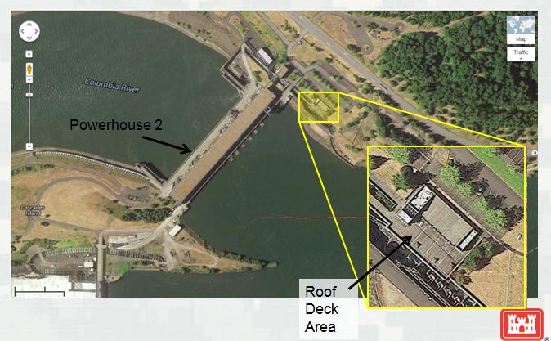
Photo 1. Arial view of Powerhouse 2 and the Washington Shore fishway.

Repairs include the removal of caulking in the expansion joints, pressure washing the entire surface, and laying a rhino-liner like material over the top. The work area will include the flat surface with the sloped section as an optional item.

Caulking removal will be completed by hand. There will be no heavy equipment used. The only equipment likely to cause noise/vibration would be the pressure washer. Water will not drain into the fishway. The pressure washer will be used to clean the surface so a durable coating may be applied.
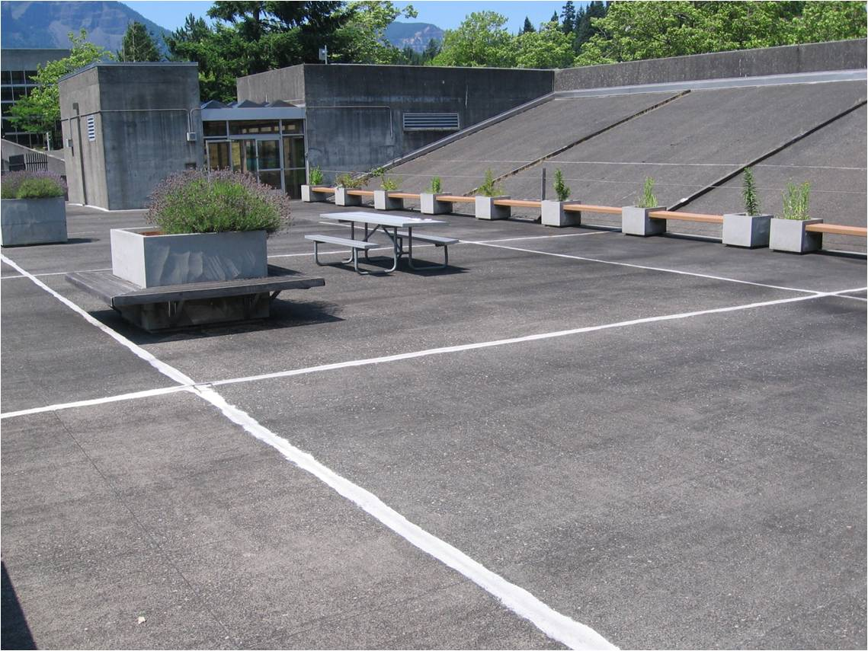
Photo 2. Close up of the roof area to be repaired and the caulking to be removed.

Type of outage required – The Fish Viewing Building may be closed to visitors, or have restricted areas, during the repairs.

Impact on facility operation – There will be no impact on the facility operation. Fish Counters will still have access to the count station.

Dates of impacts/repairs – The contract will be final by late April. Work on the roof would be in late July – early August.

Length of time for repairs – No more than two weeks.

Expected impacts on fish passage – Monthly updates will be provided to FPOM to ensure contract changes do not impact fish passage.

Upstream passage – This work will occur within This work will occur within 50’ of the fishway, however, it is expected that noise/vibration will be minimal since no heavy equipment will be used.
Table 1. 10-yr average (2005 – 2014) Fish Counts for BON by Ladder and Species.
DATE | Chinook |  | Steelhead |  | Coho |  | Sockeye
 | WS | BI | WS | BI | WS | BI | WS | BI
7/24 | 393 | 240 | 2641 | 1445 | 0 | 0 | 149 | 61
7/25 | 376 | 202 | 2820 | 1458 | 0 | 0 | 114 | 39
7/26 | 338 | 234 | 2728 | 1623 | 0 | 0 | 90 | 41
7/27 | 398 | 262 | 2775 | 1701 | 0 | 0 | 87 | 33
7/28 | 395 | 253 | 3087 | 1771 | 0 | 0 | 68 | 30
7/29 | 351 | 225 | 2961 | 1622 | 0 | 0 | 58 | 25
7/30 | 321 | 232 | 3121 | 1721 | 0 | 0 | 39 | 19
7/31 | 281 | 226 | 2861 | 1728 | 0 | 0 | 35 | 18
8/1 | 330 | 228 | 3515 | 1822 | 1 | 0 | 39 | 14
8/2 | 302 | 172 | 3062 | 1695 | 1 | 0 | 29 | 10
8/3 | 292 | 187 | 2925 | 1969 | 1 | 0 | 21 | 9
8/4 | 279 | 197 | 2719 | 2018 | 1 | 2 | 18 | 6
8/5 | 271 | 208 | 2670 | 2038 | 2 | 1 | 17 | 6
8/6 | 318 | 279 | 2759 | 2264 | 3 | 2 | 15 | 6

There tends to be a lull in most salmonid passage in late July – early August. There are still high numbers of steelhead passing during this time, but overall passage tends to be relatively low. This drop in passage has allowed BON to conduct mid-season ROVs and take care of some fish unit brushing maintenance in the past. Focusing on this time period will allow for drier weather and fewer fish. It should also allow the building to re-open to visitors prior to the coho and fall Chinook run starting.

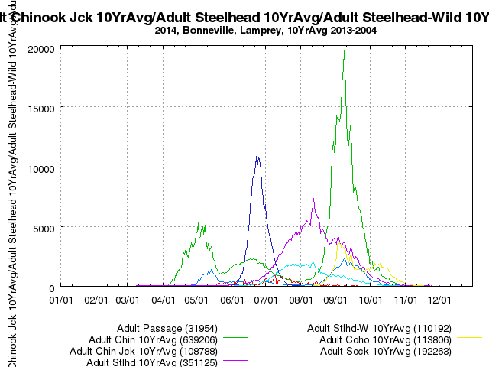

Figure 1. 10 year average passage data for BON (2004 – 2013)
DART Data Citation
Columbia River DART, Columbia Basin Research, University of Washington. (2014). Available from http://www.cbr.washington.edu/dart/query/adult_graph_text
Generated
15 Dec 2014 14:41:55 PST. Columbia River DART (Data Access in Real Time) www.cbr.washington.edu/dart.

Downstream migrants – this work will not occur within 50’ of a downstream passage facility.

Lamprey – This work will occur within 50’ of lamprey passing through the Washington Shore ladder but work will occur during the day, when fewer lamprey are passing the ladder.

Comments from agencies

Final results

Please email or call with questions or concerns.
Thank you,
Tammy

Tammy Mackey
NWP Operations Division Fishery Section
Columbia River Coordination Biologist
503-961-5733
Tammy.m.mackey@usace.army.mil

